Name
Scaffold

Table of Contents
Section 3.1 – Development (5 Marks) 2
3.1.2 — Logbook 3
Section 3.2 – Production (50 Marks) 3
3.2.1 — Web Application 3
3.2.1 — Video 3
Section 4 - Testing and Maintaining (10 Marks) 3
4.1 — Acceptance Testing 3
4.2 — Load Testing 3
4.3 — User Survey 4

Section 3.1 – Development (5 Marks)

3.1.2 — Logbook
Insert link to logbook file saved in OneDrive

Section 3.2 – Production (50 Marks)

3.2.1 — Web Application
Insert link to GitHub

3.2.1 — Video
Insert link to video file saved in OneDrive

Section 4 - Testing and Maintaining (10 Marks)

4.1 — Acceptance Testing
Apply methodologies to test and evaluate whether the application meets all outlined requirements and objectives. Describe the acceptance testing process, including test cases, scenarios, and criteria. Document the results and any necessary actions.

Verb:
- Apply: Use in a different, new or unfamiliar fashion.
- Evaluate: Make a judgement based on criteria; Determine the value of.
- Describe: Provide characteristics and features

Example:
For instance, during acceptance testing of the application, a set of test cases was developed to verify core functionalities such as user login, data submission, and report generation. Test scenarios included both typical user actions and edge cases to assess robustness. Criteria for success were established in advance, focusing on correct data processing and intuitive navigation. After executing the tests, all critical requirements were met except one minor issue with data export formatting, which was documented for correction. Overall, the results confirmed the application was ready for deployment, with only minimal adjustments needed.

Answer:
Test case
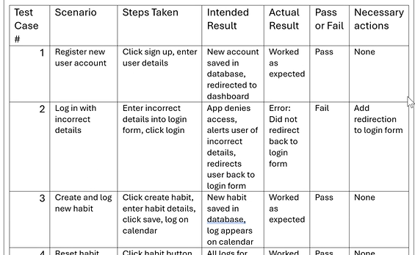THE LAST COLUB IS IMPORTANT

4.2 — Load Testing
Apply methodologies to test and evaluate the application’s stability and performance under different levels of usage and load. Detail the load testing procedures, tools, and metrics. Provide a report on the findings and recommendations for improvement.

Verb:
- Apply: Use in a different, new or unfamiliar fashion.
- Evaluate: Make a judgement based on criteria; Determine the value of.
- Describe: Provide characteristics and features

Example:
For example, during load testing, JMeter was used to simulate up to 500 concurrent users performing key actions such as login, data retrieval, and file uploads. Metrics like average response time, throughput, and error rate were recorded. The application maintained acceptable response times below 2 seconds under normal load, but response times increased significantly beyond 400 users, and occasional timeouts occurred. These findings indicated the need to optimise database queries and increase server capacity before scaling to a larger user base.

Answer:

4.3 — User Survey
Collect feedback through a survey to analyse and respond to feedback on the application’s usability, functionality, and overall satisfaction. Design a user survey with relevant questions and distribute it to a representative sample of users. Summarise the survey results and outline the changes made based on user feedback.

Verb:
- Analyse: Identify components and the relationship between them; draw out and relate implications
- Summarise: Express, concisely, the relevant details

Example:
For example, a user survey was distributed to 50 application users, asking about ease of navigation, clarity of interface, feature usefulness, and overall satisfaction. Most respondents rated navigation and clarity highly, but several noted difficulties with the data export feature. Based on this feedback, interface instructions were improved, and the export workflow was streamlined. Survey results demonstrated overall user satisfaction and highlighted actionable areas for refinement.

Answer:

